**SQL PRACTICE ASSIGNMENT**

**TABLES USED**

**TABLE 1**

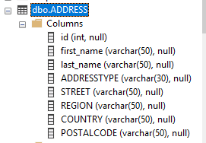

**TABLE 2**

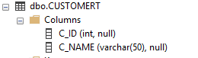

**TABLE 3**

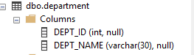

**TABLE 4**

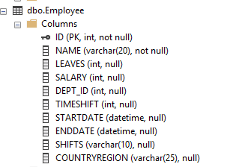

**TABLE 5**

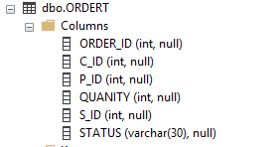

**TABLE 6**



**TABLE 7**

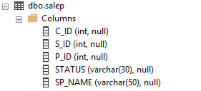

**TABLE 8**

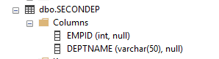

TASK 1 QUERY

SELECT * FROM Employee WHERE LEAVES=(SELECT MAX(LEAVES) FROM Employee)

OUTPUT

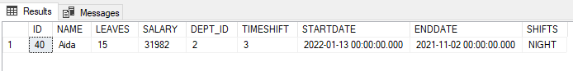

TASK 2 QUERY

SELECT * From Employee WHERE LEAVES=(SELECT MAX(LEAVES) FROM EMPLOYEE WHERE LEAVES < ( SELECT Max(LEAVES) FROM Employee));

OUTPUT

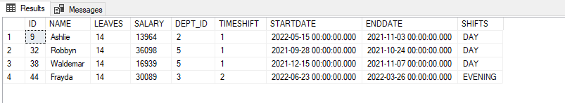

TASK 3 QUERY

SELECT TOP 1 *

FROM (

SELECT DISTINCT TOP 2 *

FROM Employee

ORDER BY salary DESC

)

as temp

ORDER BY salary

OUTPUT

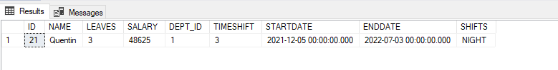

TASK 4 QUERY

SELECT ID,

D.DEPT_NAME,

E.NAME,

E.STARTDATE,

E.ENDDATE

FROM employee E INNER JOIN department D ON E.DEPT_ID=D.DEPT_ID

ORDER BY NAME,STARTDATE ASC ;

OUTPUT

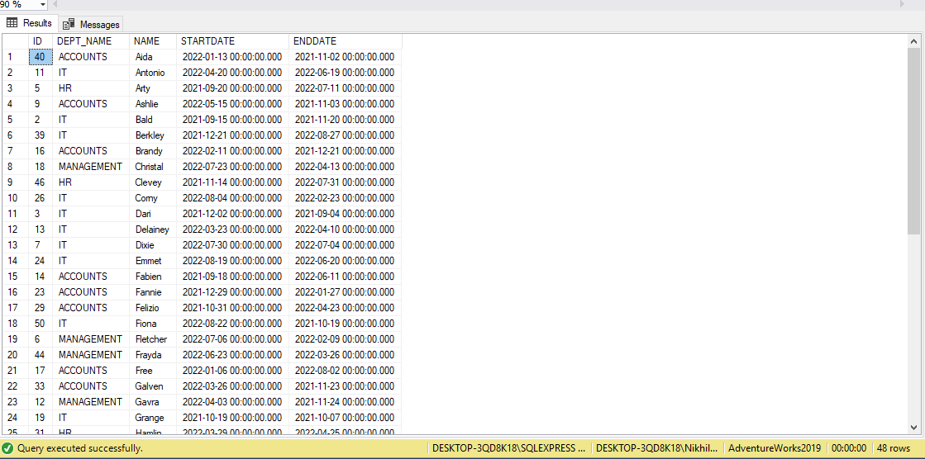

TASK 5 QUERY

SELECT EMPLOYEE.NAME,SECONDEP.EMPID,COUNT(SECONDEP.EMPID) AS TOTAL_DEPARTMENT

FROM Employee

INNER JOIN SECONDEP

ON ID = SECONDEP.EMPID

GROUP BY SECONDEP.EMPID,Employee.NAME

HAVING COUNT(*) > 1;

OUTPUT

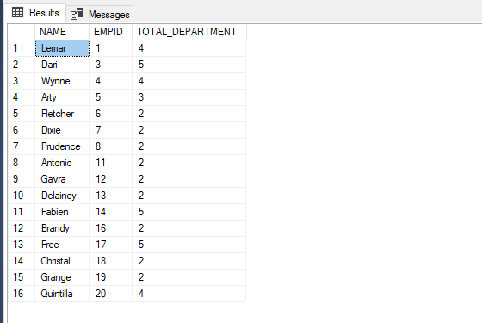

TASK 6 QUERY

SELECT COUNT(*) AS NO_DEPARTMENT FROM EMPLOYEE WHERE DEPT_ID=0

OUTPUT



**TASK 7 QUERY**

SELECT SHIFTS, COUNT(*) AS EMPLOYEES

FROM Employee

GROUP BY SHIFTS;

**OUTPUT**

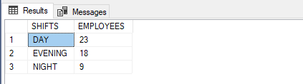

**TASK 8**

SELECT countryregion,COUNT(*) AS countryregioncount

FROM EMPLOYEE

GROUP BY COUNTRYREGION

ORDER BY countryregioncount

**OUTPUT**

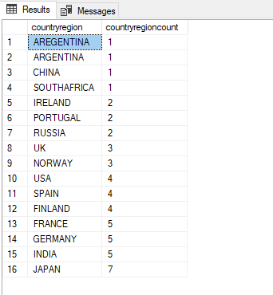

**TASK 9 QUERY**

SELECT TOP(1) countryregion,COUNT(*) AS countryregioncount

FROM EMPLOYEE

GROUP BY COUNTRYREGION

ORDER BY countryregioncount DESC

**OUTPUT**

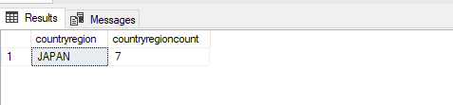

**TASK 10 QUERY**

SELECT FIRST_NAME,LAST_NAME ,CONCAT(STREET , '-', REGION , '-' ,COUNTRY , '-' ,POSTALCODE ) AS ADDRESSTYPE FROM ADDRESS

**OUTPUT**

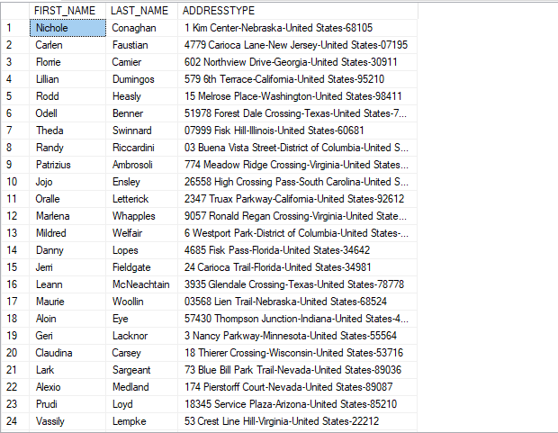

**TASK 11 QUERY**

SELECT * FROM ADDRESS WHERE ADDRESSTYPE NOT IN ('HOME+SHIPPING','WORK+SHIPPING')

**OUTPUT**

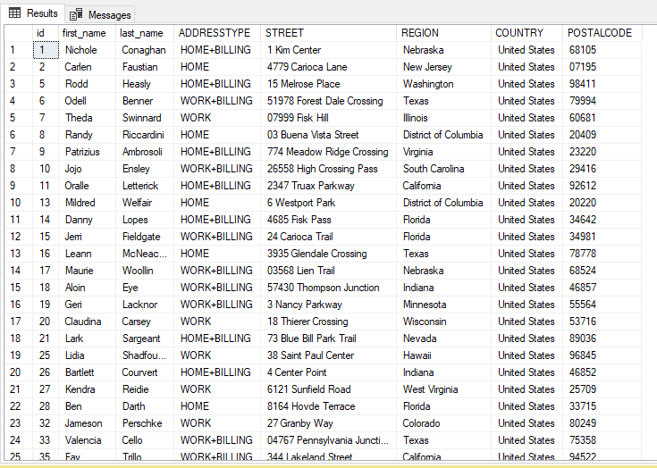

**TASK 12 QUERY**

SELECT * FROM ADDRESS WHERE ADDRESSTYPE LIKE '%HOME+BILLING%'

**OUTPUT**

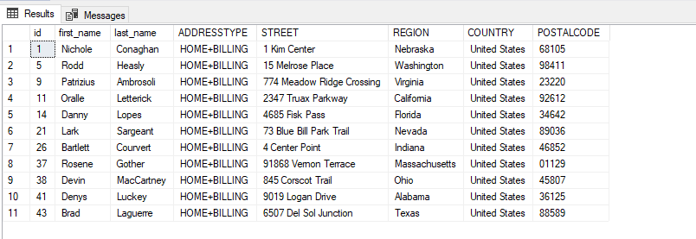

**TASK 13 QUERY**

SELECT REGION, COUNT(REGION) AS TOTALEMPLOYEE FROM ADDRESS WHERE REGION ='TEXAS' GROUP BY REGION

**OUTPUT**

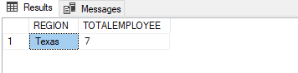

**Task 14 QUERY**

SELECT C.C_ID,C.C_NAME,P.P_ID,P.P_NAME,P.PRICE,O.QUANITY,P.PRICE*O.QUANITY AS TOTALSALE FROM CUSTOMERT C INNER JOIN ORDERT O ON C.C_ID=O.C_ID INNER JOIN PRODUCTT P ON O.P_ID=P.P_ID

**OUTPUT**

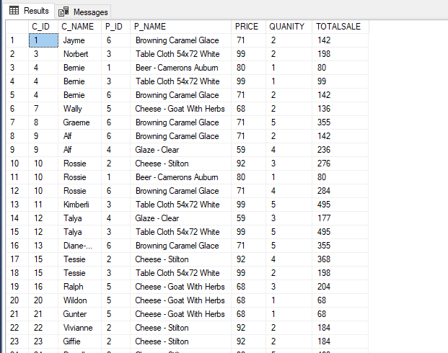

**TASK 15 QUERY**

SELECT TOP(1) S.SP_NAME, COUNT(O.S_ID) AS HIGHESTSALE from salep S INNER JOIN

ORDERT O ON S.S_ID=O.S_ID

GROUP BY O.S_ID,S.SP_NAME ORDER BY HIGHESTSALE DESC

**OUTPUT**

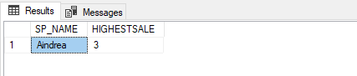

**TASK 16 QUERY**

SELECT STATUS , COUNT(STATUS) AS COMPARISON FROM salep GROUP BY STATUS

**OUTPUT**

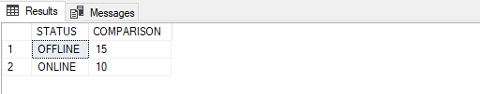

**TASK 17 QUERY**

SELECT STATUS,COUNT(STATUS) AS UPDATES FROM ORDERT GROUP BY STATUS

**OUTPUT**

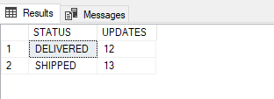

**OUTPUT**

**TASK 18 QUERY**

SELECT O.P_ID ,P.P_NAME, COUNT(O.P_ID) AS CUSTOMERS FROM ORDERT O INNER JOIN PRODUCTT P ON O.P_ID=P.P_ID GROUP BY O.P_ID,P.P_NAME ORDER BY CUSTOMERS DESC

**OUTPUT**

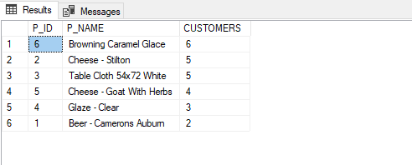

**TASK 19 QUERY**

SELECT TOP(1) O.P_ID ,P.P_NAME AS POPULARPRODUCT, COUNT(O.P_ID) AS CUSTOMERS FROM ORDERT O INNER JOIN PRODUCTT P ON O.P_ID=P.P_ID GROUP BY O.P_ID,P.

**OUTPUT**

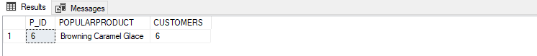

**TASK 20 QUERY**

SELECT T.P_NAME,SUM(O.QUANITY*T.PRICE) AS REVENUE FROM ORDERT O INNER JOIN PRODUCTT T ON O.P_ID=T.P_ID GROUP BY T.P_NAME

**OUTPUT**

